MANDATORY DISCLOSURE

The details furnished below as on 05/04/2022 and true to our best knowledge

- Name of the Institution
MANIPAL INSTITUTE OF TECHNOLOGY -BENGALURU, KARNATAKA STATE, INDIA.
Email: director.mitblr@manipal.edu

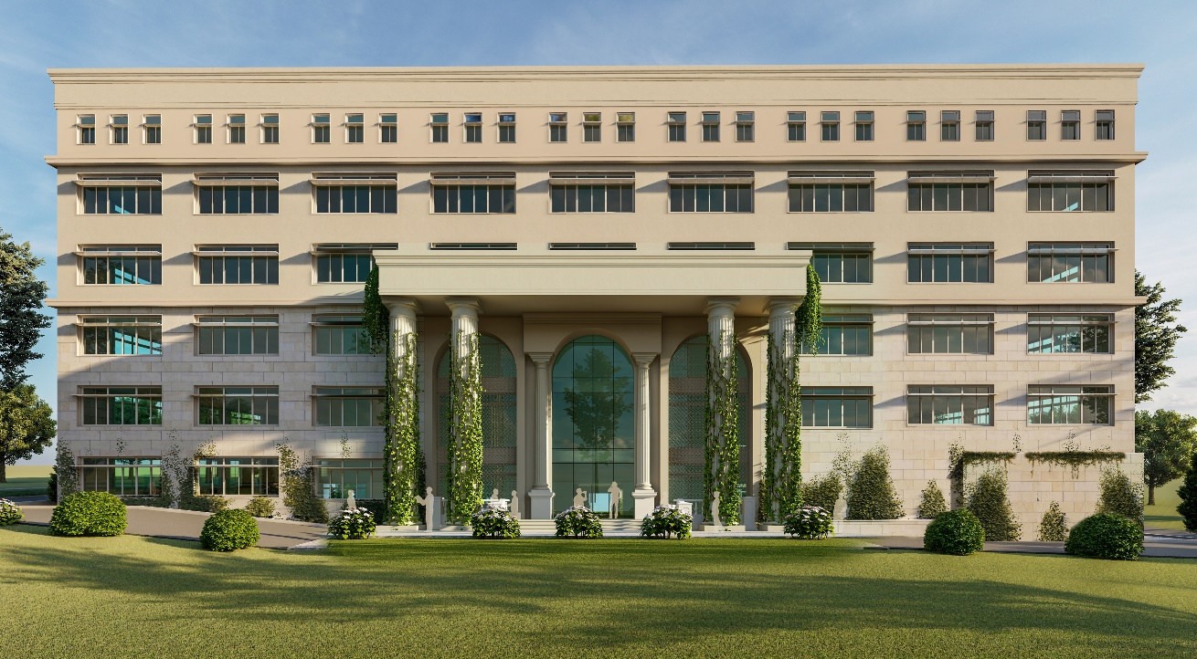

The Garden City of India, Bengaluru, is now home to a new Engineering institution – “MIT Bengaluru” at the off campus centre of Manipal Academy of Higher Education (MAHE), Bengaluru. MAHE is proud to open its doors in the bustling cosmopolitan IT hub of Bengaluru by establishing its new engineering campus: MIT Bengaluru. MIT, Bengaluru offers five B Tech programs starting from 2021, with approval from the All India Council of Technical Education (AICTE), MHRD, Government of India. The five approved programs are Computer Science and Engineering, Information Technology, Electronics and Communication, Computer Science and Engineering (Artificial Intelligence) and Computer Science and Engineering (Cyber Security). MAHE is recognized as a deemed-to-be university since 1993 and has been accorded the status of Institute of Eminence (IoE) by MHRD, Government of India. Admission to MIT Bengaluru is based on a computer-based online entrance test, MET, conducted by MAHE.

- Name and address of the Trust/ Society/ Company and the Trustees

TRUST:
MANIPAL ACADEMY OF HIGHER EDUCATION TRUST, MANIPAL – 576 104, UDUPI DISTRICT, KARNATAKA STATE, INDIA. Ph: 0820-2922323; registrar@manipal.edu

DETAILS OF TRUSTEES OF MANIPAL ACADEMY OF HIGHER EDUCATION TRUST
Sl # | Trustee Name | Designation | Address | Trustee since | Trustee Till | Email-id | Age (as on March 2022) | Father name | Residence of
1 | Dr. Ranjan R Pai | President & Chairman | Registrar, Academy of General Education (AGE), Manipal  Chairman, MEMG India International Pvt Ltd., JW Marriott Bengaluru- 560001 | 13.10.2017 | 12.10.2024 | president@manipal.edu | 49 yrs | Dr.Ramdas M. Pai | India
2 | Dr. Ramdas M Pai | Trustee | Chancellor  MAHE, Manipal 576 104 | 22.05.1993 | For life | chancellor@manipal.edu | 87 yrs | Late Dr.T.M.A.Pai | India
3 | Mr. T Ashok Pai | Trustee | Secretary, Dr TMA Pai Foundation, Syndicate House, Manipal 576 104 | 13.10.2017 | 12.10.2024 | drtmapaifoundation@rediffmail.com | 73 yrs | Late Dr.T.M.A.Pai | India
4 | Mr. T Mohandas Pai | Trustee | 9, Ananth Nagar, Manipal 576 104 | 13.10.2017 | 12.10.2024 | No email id | 89 yrs | Late Dr.T.M.A.Pai | India
5 | Mr. T Satish U Pai | Trustee | Managing Director, Manipal Media Network Ltd, Udayavani Building, Manipal 576 104 | 13.10.2017 | 12.10.2024 | satishpai@manipalmedia.com | 80 yrs | Late Mr.T.Upendra A.Pai | India
6 | Mrs. Vasanti R. Pai | Trustee | Geetanjali, Manipal 576 104 | 07.07.2018 | 06.07.2023 | vasanti.pai@manipal.edu | 80 yrs | Late Sarvotham Laxman Pai | India
7 | Mr. T V Mohandas Pai | Trustee | Chairman, Manipal Global Education Services, Pvt Ltd., 15th Floor, JW Marriott Bengaluru, 24/1, Vittal Mallya Road (Next to UB City), Bengaluru – 560001 | 13.10.2017 | 12.10.2024 | mohan.pai@manipalglobal.com | 63 yrs | Late Mr.T.V.Ramana Pai | India
8 | Dr. H S Ballal | Trustee | Pro Chancellor, Manipal Academy of Higher Education, Manipal and President, Academy of General Education, Manipal | 13.10.2017 | 12.10.2024 | prochancellor@manipal.edu | 81 yrs | Late Mr. B.Sanjeeva Hegde | India

- Name and Address of the Director
Dr. JAGANNATH K, DIRECTOR, MANIPAL INSTITUTE OF TECHNOLOGY, BENGALURU – 560064, KARNATAKA STATE, INDIA.
Email : jagannath.korody@manipal.edu;
Mob: 9116629861

- Name of the affiliating University
MANIPAL ACADEMY OF HIGHER EDUCATION, MANIPAL

- Governance
  - Members of the Board and their brief background: complied with
  - Members of Academic Advisory Body: complied with
  - Frequency of the Board Meeting and Academic Advisory Body: Complied with
Organizational chart and processes:
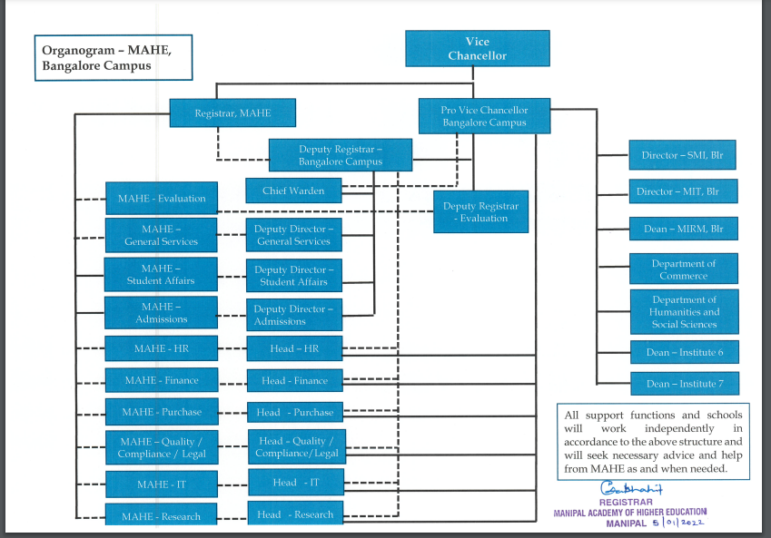
  - Nature and Extent of involvement of Faculty and students in academic affairs/improvements
- Outcome based education system is followed.
- Faculty recruitment is as per AICTE norms.
- ICT tools are used for teaching-learning, assessment and evaluation.
- Performance evaluation of faculty in terms of their academics, research and administration with additional incentive.
- Students are involved in research activities and incentives for publication and other achievements.
  - Mechanism/ Norms and Procedure for democratic/ good Governance
- Curriculum is as per industry norms and is designed by involving all stakeholders.
- Transparent system for assessment and evaluation, examination using e-pads
- Industry participation in academic delivery.
  - Student Feedback on Institutional Governance/ Faculty performance
- Systemic processes set for student feedback system and its evaluation and further actions.
  - Grievance Redressal mechanism for Faculty, staff and students

S.No. | Name | Designation | Designation in Committee | Email.Id
1 | Prof. Jagannath K | Director | Chairperson | jagannath.korody@manipal.edu
2 | Dr. Prema K V | HOD-CSE | Member | prema.kv@manipal.edu
3 | Dr. Ujjwal Verma | HOD-ECE | Member | ujjwal.verma@manipal.edu
4 | Mr.Shashank Benakatti | Student | Member | shashank.b322@gmail.com
5 | Ms. Rutuja Patil | Student | Member | rutuja.patil2308@gmail.com
6 | Mr. Hrishit Dhoka | Student | Member | hrishitdhoka@gmail.com
7 | Mr. Mahipal Bukya | Assistant Professor (Senior-Scale) | Convener | mahipal.bukya@manipal.edu

Online Grievance Redressal Registration at Manipal Institute of Technology Bengaluru
Click here to submit https://rb.gy/82g2gf

Faculty Grievance Redressal Committee (GRC):

Chairperson: Prof. Jagannath K, Director
Convener: Mahipal Bukya, Assistant Professor (Senior-Scale)
Members: Dr. Prema K V, CSE-HoD, Professor
Dr. Ujjwal Verma, ECE-HoD, Associate Professor
- Establishment of Anti Ragging Committee
Sl. No. | Name | Designation | Contact No. | Email id
1. | Dr. Jagannath K, Director | Chairperson | 9448162655 | jagannath.korody@manipal.edu
2. | Mr. Adithya G S S | Member | 7073084884 | srinivas.adithya@manipal.edu
3. | Mr. Mahipal Bukya | Member | 9521099200 | mahipal.bukya@manipal.edu
4. | Dr. Ramya M | Member | 8825865352 | ramya.manohar@manipal.edu
5. | Dr. Prasanna Poojary | Nodal Officer | 9535622029 | poojary.prasanna@manipal.edu
6. | Miss Pradyota Kirtikar | Student Member | 8317075967 | pradyota.kirtikar@learner.manipal.edu
7. | Mr. Adithya R S | Student Member | 9980681503 | aditya.s12@learner.manipal.edu
8. | Mr. Kartik Mittal | Student Member | 8057503962 | kartik.mittal@learner.manipal.edu

Institutional Anti-Ragging Squad:
- Dr. Prasanna Poojary, Assistant Professor, Nodal Officer
- Dr. Deepti Gupta, Warden, Assistant Professor (Senior-Scale), MIT Bengaluru
- Mr. Adithya G S S, Warden, Assistant Professor (Senior-Scale), MIT Bengaluru
- Members of Advisory (Anti Ragging Enquiry) Committee
- All Deputy Wardens
- All Block Wardens
- All Teacher-Guardians of I & II Semester
- President and Members of Student Council

- Establishment of Internal Complaint Committee (ICC):

S.No | Name | Designation | Phone No. | Email ID
1. | Dr. Mamatha D Daivajna | Chairperson | 9116629861 | mamatha.daijna@manipal.edu
2. | Ms. Latha Holla | Legal Advisor | 9945062119 | lathaholla08@gmail.com
3. | Dr. Deepti Gupta | Nodal Officer | 9911797669 | deepti.gupta@manipal.edu
4. | Dr. Manohara. J. D. | Member | 8660406133 | jd.manohar@manipal.edu
5. | Dr. Suman Das | Member | 9804353307 | das.suman@manipal.edu
6. | Sherone Tanishka D'Souza | Student | 7411791663 | sherone.dsouza@learner.manipal.edu
7. | Palthepu Saisahith | Student | 7702779132 | palthepu.saisahith@learner.manipal.edu
8. | Hima varshini | Student | 9392499334 | hima.varshini@learner.manipal.edu

- The committee will be responsible for hearing and disposing all the complaints regarding Sexual Harassment in the campus.
- Any student or employee who feels that he/she is being sexually harassed, directly or indirectly, may submit a complaint of the alleged incidents(s) in writing complaints may be sent via email at mamatha.daijna@manipal.edu or dropped in a sealed envelope to the Director, MIT-BLR.

  - Establishment of Committee for SC/ ST –complied with

  - Internal Quality Assurance Cell:
S.No. | Name | Designation | Designation in IQAC
1 | Dr. Jagannath K | Director | Chairperson
2 | Dr. Ambedkar Dukkipati | Professor  Computer Science and Automation,  Indian Institute of Science (IISc), Bengaluru | Academic External Expert
3 | Dr. Ranga Srinivas Gunti | Senior DGM, Mahindra &-Mahindra Chennai,  Adjunct Faculty (Honorary), Indian Institute of Technology (IIT), Madras | Industry Expert
4 | Dr. Vidya Shankar Shetty | Deputy Registrar | Administrative Member
5 | Dr. Ramachandra V. Murty | QMR- Nodal Officer, MIT Manipal | Academic External Expert
6 | Dr. Subba Reddy N V | HOD-IT, Coordinator for Strategic Planning & Student engagement on Saturdays | Member
7 | Dr. Prema K V | HOD-CSE, MITB Budget 2022-23. Coordinator | Member
8 | Dr. Ravi Kumar Gupta | Overall coordinator for First year | Member
9 | Dr. Ujjwal Verma | HOD-ECE, Coordinator for Research Grant, Consultancy and IPR coordinator | Member
10 | Dr. Mamatha D. Daivajna | Examination Coordinator | Member
11 | Dr. Ramasamy | Academics coordinator | Member
12 | Mr. Adithya G S S | Student Welfare Coordinator | Member
13 | Ms. B Harshamallika | Electronics and Communication Engineering | Student Member
14 | Mr. Khasib Ruhaan | Information Technology | Student Member
15 | Mr. Arnav Puri | Computer Science & Engineering [Artificial Intelligence] | Student Member
16 | Mr. Prakul R Pathange | Computer Science & Engineering [Cyber Security] | Student Member
17 | Ms. Vanishka Gupta | Computer Science Engineering | Student Member
18 | Dr. Prasanna Poojary | Assistant Professor | Co-Coordinator
19 | Mr. Mahipal Bukya | Assistant Professor (Senior-Scale) | Coordinator

- Programmes
  - Name of Programmes approved by AICTE

UNDERGRADUATE:
- COMPUTER SCIENCE AND ENGINEERING
- INFORMATION TECHNOLOGY
- ELECTRONICS AND COMMUNICATION
- COMPUTER SCIENCE AND ENGINEERING – ARTIFICIAL INTELLIGENCE
- COMPUTER SCIENCE AND ENGINEERING – CYBER SECURITY

  - Status of Accreditation of the Courses : Not eligible
Total number of Courses

UNDERGRADUATE: 5

For each programme the following details are to be given:

UNDERGRADUATE

Name | Number of  Seats | Duration | Fee  (2022-23)
Computer Science and Engineering | 60 | 4 Years | 18,62,000
Information Technology | 60 | 4 Years | 18,62,000
Electronics and Communication Engineering | 60 | 4 Years | 18,62,000
Computer Science and Engineering – Artificial Intelligence | 60 | 4 Years | 18,62,000
Computer Science and Engineering – Cyber Security | 60 | 4 Years | 18,62,000

- Faculty
Please visit: https://manipal.edu/mu/campuses/mahe-bengaluru/academics/institution-list/mitblr/department-faculty.html

- Permanent Faculty: Student Ratio – UG: 1:17.64
- Number of Faculty employed and left during the last one year

Year | Employed | Left
2021 | 18 | 0
2022 | 2 | 1

- Profile of the Director
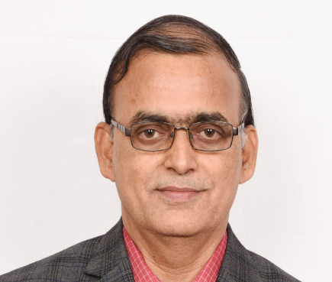

  - Name: Dr. Jagannath K
  - Date of Birth: 27/02/1961
  - Education Qualifications: B.E.; M.Tech.; PhD
  - Work Experience
Dr. Jagannath Korody is the Director of the Engineering Program at MIT- Bengaluru Campus. Before this assignment, he has worked as Dean, Faculty of Engineering at Manipal University, Jaipur, Rajasthan, for three years. Dr. Korody has more than 35 years of teaching and research experience in technical education.
- Area of Specialization: Tribology, Refrigeration & Air conditioning, Cryogenics

- Fee: https://manipal.edu/content/dam/manipal/mu/documents/Admissions/adm2022/2022_MAHE_Manipal_General_Category_Program_Fees.pdf

- Admission Procedure: https://manipal.edu/mu/admission.html

- Information of Infrastructure (Academic, Hostel and others) Resources Available

Academic Block
Sl.No | Building | In. s. No/Village | Plinth Area in Sqft | Plinth Area in Sqm | Built up Area in Sqft | Built up Area in Sqm
1 | Academic Block 4 | Sy no 5(P), 9(P) of Vasudevapura village | 6737.77 | 2484 | 195132.48 | 18128.25

Hostel Facility:
Sl.No | Building | In. s. No/Village | Plinth Area in Sqft | Plinth Area in Sqm | Built up Area in Sqft | Built up Area in Sqm
1 | Hotel Block 1 | Sy no 4(P)of Govindapura village | 18772.41 | 1744 | 111581.66 | 10366.19
2 | Hotel Block 2 | Sy no 4(P)of Govindapura village | 18772.41 | 1744 | 111581.66 | 10366.19

Other Major Resources
  - Number of Class Rooms & Laboratories
Building | Room Type(Mention Class room/Laboratory/Toilet etc) | Carpet area (in m2)
Academic Block 4 | Classrooms [ 12 Nos] | 1432
Academic Block 4 | Labs [10 Nos] | 721
Academic Block 4 | Workshop [ 1 No] | 234
Academic Block 4 | Physics Lab [2 Nos] | 197
Academic Block 4 | Chemistry Lab [2 Nos] | 197
Academic Block 4 | Seminar Hall [ 1 No] | 144
Academic Block 4 | Tutorials [10 Nos] | 324
Academic Block 4 | Drawing Hall [2 Nos] | 214
Academic Block 4 | Electronics Lab [ 2 Nos] | 225
Academic Block 4 | Language Labs [ 1 No] | 67
Academic Block 4 | Computer Centre [ 1 No] | 114
Academic Block 4 | Library | 700

  - Occupancy Certificate: Complied With
  - Fire and Safety Certificate: Complied With

List of Major Equipment/Facilities in each Laboratory/ Workshop
Department | Lab/Major Equipments
Physics lab | - Newtons rings  - Hall effect kit  - Boltzman constant kit  - Fermi energy kit  - Energy band gap kit  - Black body radiation kit  - Series and parallel resonance kit  - Diffraction grating kit  - Double refraction kit  - Photoelectric effect kit  - Ultrasonic interferometer kit
Chemistry lab | - Conductometers with conductivity cell  - pH meters with combined glass electrode  - Platinum electrode  - Calomel Electrode  - Combined pH electrode  - Digital pH meter  - Calorimeters with Cuvettes  - LPG cylinder with pipes and controller system  - Dionized water  - Fume exhaust hood  - Viscometers
Workshop | - Model of 2 stroke and 4 stroke engine  - Model of Electric vehicle  - CNC machine  - Software for CNC programming  - Software for determining shear force and bending moment  - Building layout planning software  - Study of wiring tools, Fuses, Circuit breakers  - Lighting sources, two-way switches, fluorescent lamp wiring  - Electrical energy measurement in Single-phase and three-phase circuits  - Soldering practices with basic electrical circuits on PCB  - Resistor, capacitors, Diodes  - Cathode Ray Oscilloscope  - PN junction diode
Engineering Graphics lab | AutoCAD software
Problem solving using computers lab | C, C++, MATLAB
Language lab | Clarity software

- Internet Bandwidth: 310 MBPS
- Total number of Computer: 220
- Total number of computers connected by LAN: All
- Games and Sports Facilities/Indoor Games
- Football Ground
- Cricket Ground
- Tennis Court
- Basketball Court
- Badminton Court
- Gymnasium
- Athletic Ground

Curricula and syllabus for each of the programmes as approved by the University https://manipal.edu/mu/campuses/mahe-bengaluru/academics/institution-list/mitblr/department-faculty.html

